Assignment1

1.

(a)

load('0_1_2.mat');

mu = mean(X,2);

a = X - mu*ones(1,300);

[u,s,v]=svd(a);

b=u(:,1:2)'*a;

plotimages(reshape(X,8,8,300),b,0.05,0.5)

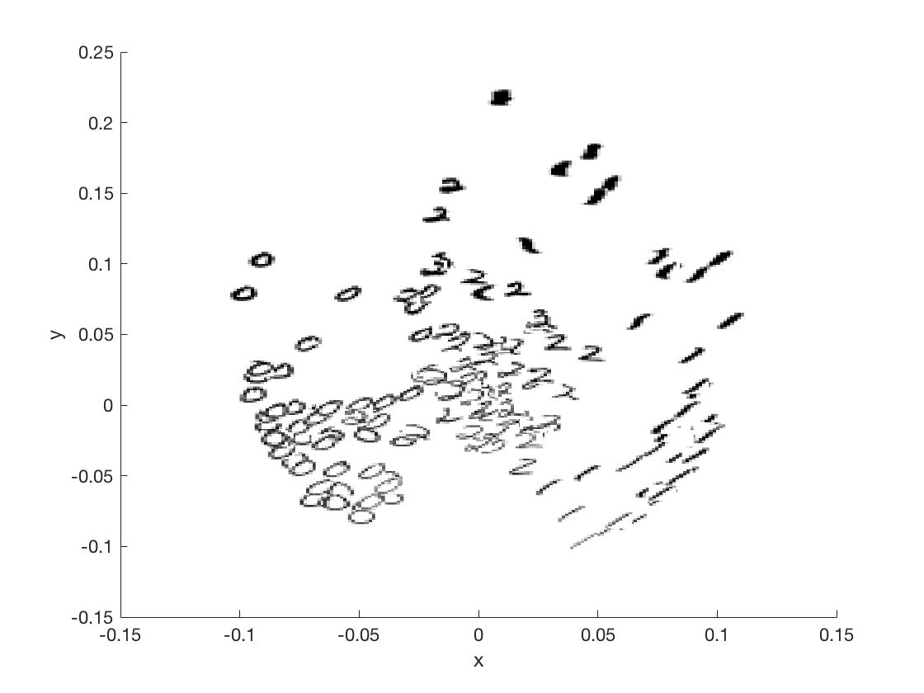

(b)

x1=X(:,1:100);

x2=X(:,101:200);

x3=X(:,201:300);

n1=100;

n2=100;

n3=100;

mu_1=0

for i=1:n1

    mu_1=mu_1+x1(:,i);

end

mu1=1/n1*mu_1

sigma_1=0

for i=1:n1

    sigma_1=sigma_1+(x1(:,i)-mu1)*(x1(:,i)-mu1)'

end

sigma1=1/36*sigma_1;

mu_2=0

for i=1:n2

    mu_2=mu_2+x2(:,i);

end

mu2=1/n2*mu_2;

sigma_2=0

for i=1:n2

    sigma_2=sigma_2+(x2(:,i)-mu2)*(x2(:,i)-mu2)'

end

sigma2=1/36*sigma_2;

mu_3=0

for i=1:n3

    mu_3=mu_3+x3(:,i);

end

mu3=1/n3*mu_3;

sigma_3=0

for i=1:n3

    sigma_3=sigma_3+(x3(:,i)-mu3)*(x3(:,i)-mu3)'

end

sigma3=1/36*sigma_3;

sigma_0=0

for i=1:300

    sigma_0=sigma_0+(X(:,i)-mu)*(X(:,i)-mu)'

end

sigma=1/236*sigma_0;

sw=sigma1+sigma2+sigma3;

sb=sigma-sw;

[v,u] = eig(inv(sw)*sb);

b2=v(:,1:2)'*a;

plotimages(reshape(X,8,8,300),b2,0.01,0.5);

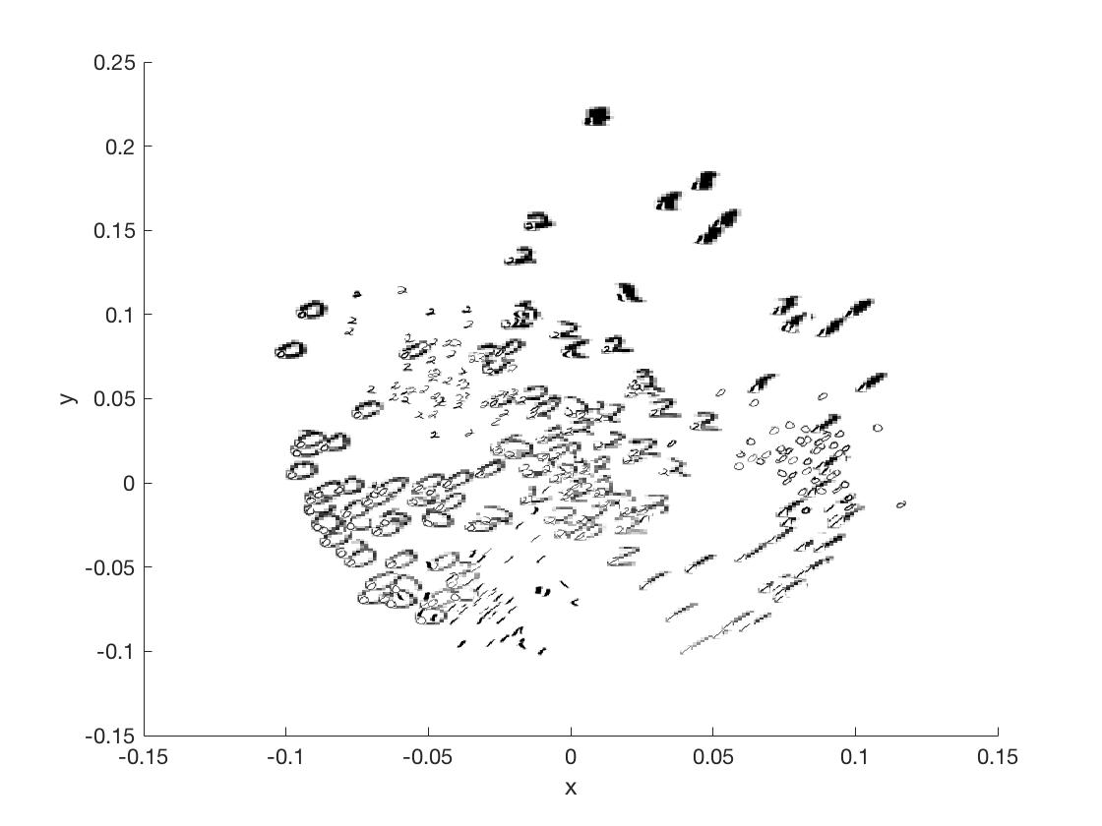

(c-LDA)

mu0_b=mean(b(:,1:100),2);

mu1_b=mean(b(:,101:200),2);

mu2_b=mean(b(:,201:300),2);

sigma_b=cov(b');

plotimages(reshape(X,8,8,300),b,0.01,1);

hold on;

a_1=(mu2_b'-mu1_b')*(inv(sigma_b));

a_0=(1/2)*((mu1_b'*inv(sigma_b)*mu1_b)-(mu2_b'*inv(sigma_b)*mu2_b));

syms x y

h2 = ezplot((a_1(1)*x+a_1(2)*y+a_0),[-3,3]);

h2.Color = 'r';

hold on

a_2=mu2_b'*inv(sigma_b)-mu0_b'*inv(sigma_b);

a_3=(1/2)*((mu0_b'*inv(sigma_b)*mu0_b)-(mu2_b'*inv(sigma_b)*mu2_b));

syms x y

h3 = ezplot((a_2(1)*x+a_2(2)*y+a_3),[-3,3]);

h2.Color = 'b';

hold on

a_1=mu1_b'*inv(sigma_b)-mu0_b'*inv(sigma_b);

a_0=(1/2)*((mu0_b'*inv(sigma_b)*mu0_b)-(mu1_b'*inv(sigma_b)*mu1_b));

syms x y

h3 = ezplot((a_1(1)*x+a_1(2)*y+a_0),[-3,3]);

h2.Color = 'y';

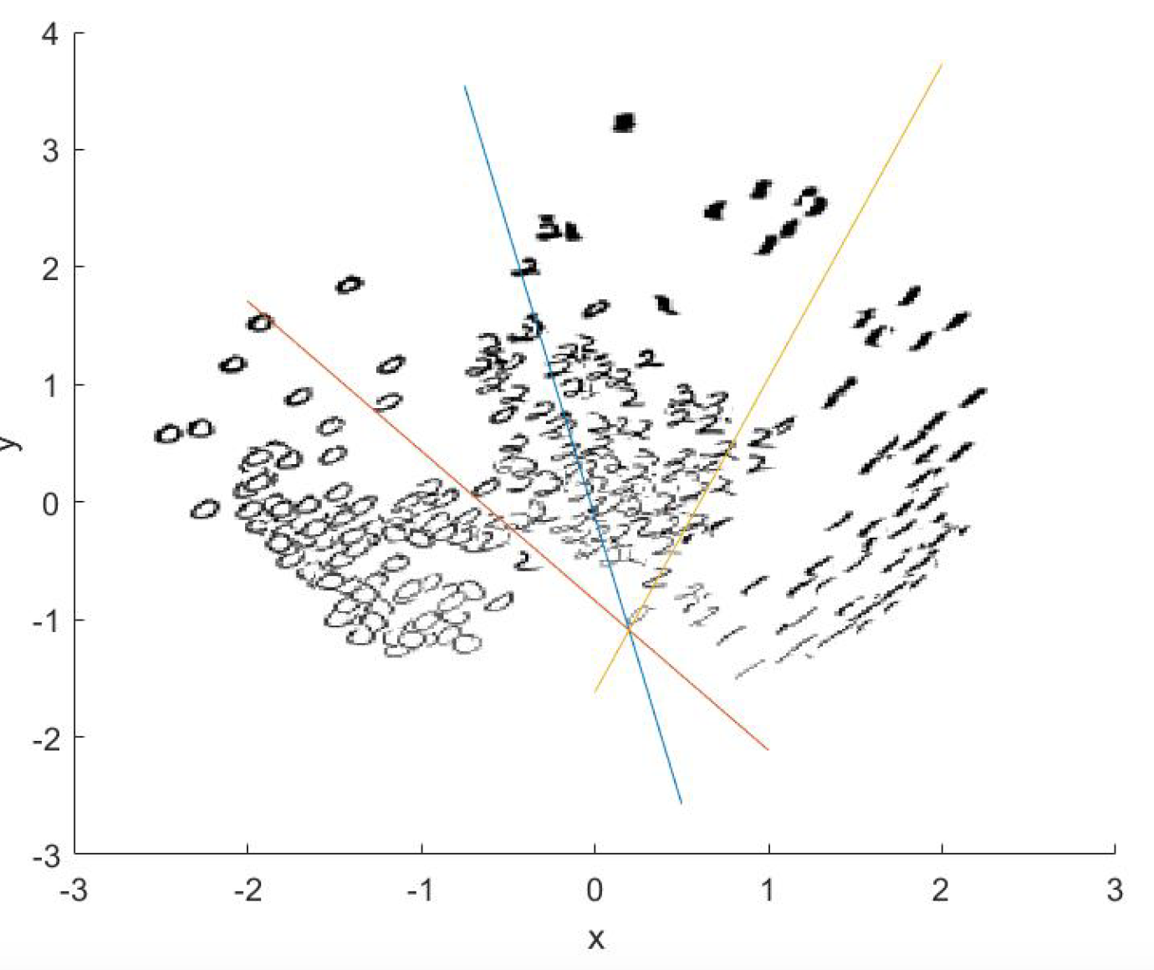

(c-QDA)

load('0_1_2.mat');

mu = mean(X,2);

a = X - mu*ones(1,300);

[u,s,v]=svd(a);

b=u(:,1:2)'*a;

plotimages(reshape(X,8,8,300),b,0.05,0.5)

sigma0=cov(b(:,1:100)');

sigma1=cov(b(:,101:200)');

sigma2=cov(b(:,201:300)');

a0_1=inv(sigma0)-inv(sigma1);

b0_1=2*(mu0_b'*inv(sigma0)-mu1_b'*inv(sigma1));

c0_1=mu0_b'*inv(sigma0)*mu0_b-mu1_b'*inv(sigma1)*mu1_b+log(det(sigma0))-log(det(sigma1));

a1_2=inv(sigma1)-inv(sigma2);

b1_2=2*(mu1_b'*inv(sigma1)-mu2_b'*inv(sigma2));

c1_2=mu1_b'*inv(sigma1)*mu1_b-mu2_b'*inv(sigma2)*mu2_b+log(det(sigma1))-log(det(sigma2));

a0_2=inv(sigma0)-inv(sigma2);

b0_2=2*(mu0_b'*inv(sigma0)-mu2_b'*inv(sigma2));

c0_2=mu0_b'*inv(sigma0)*mu0_b-mu2_b'*inv(sigma2)*mu2_b+log(det(sigma0))-log(det(sigma2));

plotimages(reshape(X,8,8,300),Ya,0.01,1);

hold on

syms x y

set(ezplot(a0_1(2,2)*y^2+(a0_1(2,1)*x+a0_1(1,2)*x-b0_1(2))*y+a0_1(1,1)*x^2-b0_1(1)*x+c0_1,[-6,6]));

hold on

set(ezplot(a0_2(2,2)*y^2+(a0_2(2,1)*x+a0_2(1,2)*x-b0_2(2))*y+a0_2(1,1)*x^2-b0_2(1)*x+c0_2,[-6,6]));

hold on

set(ezplot(a1_2(2,2)*y^2+(a1_2(2,1)*x+a1_2(1,2)*x-b1_2(2))*y+a1_2(1,1)*x^2-b1_2(1)*x+c1_2,[-6,6]));

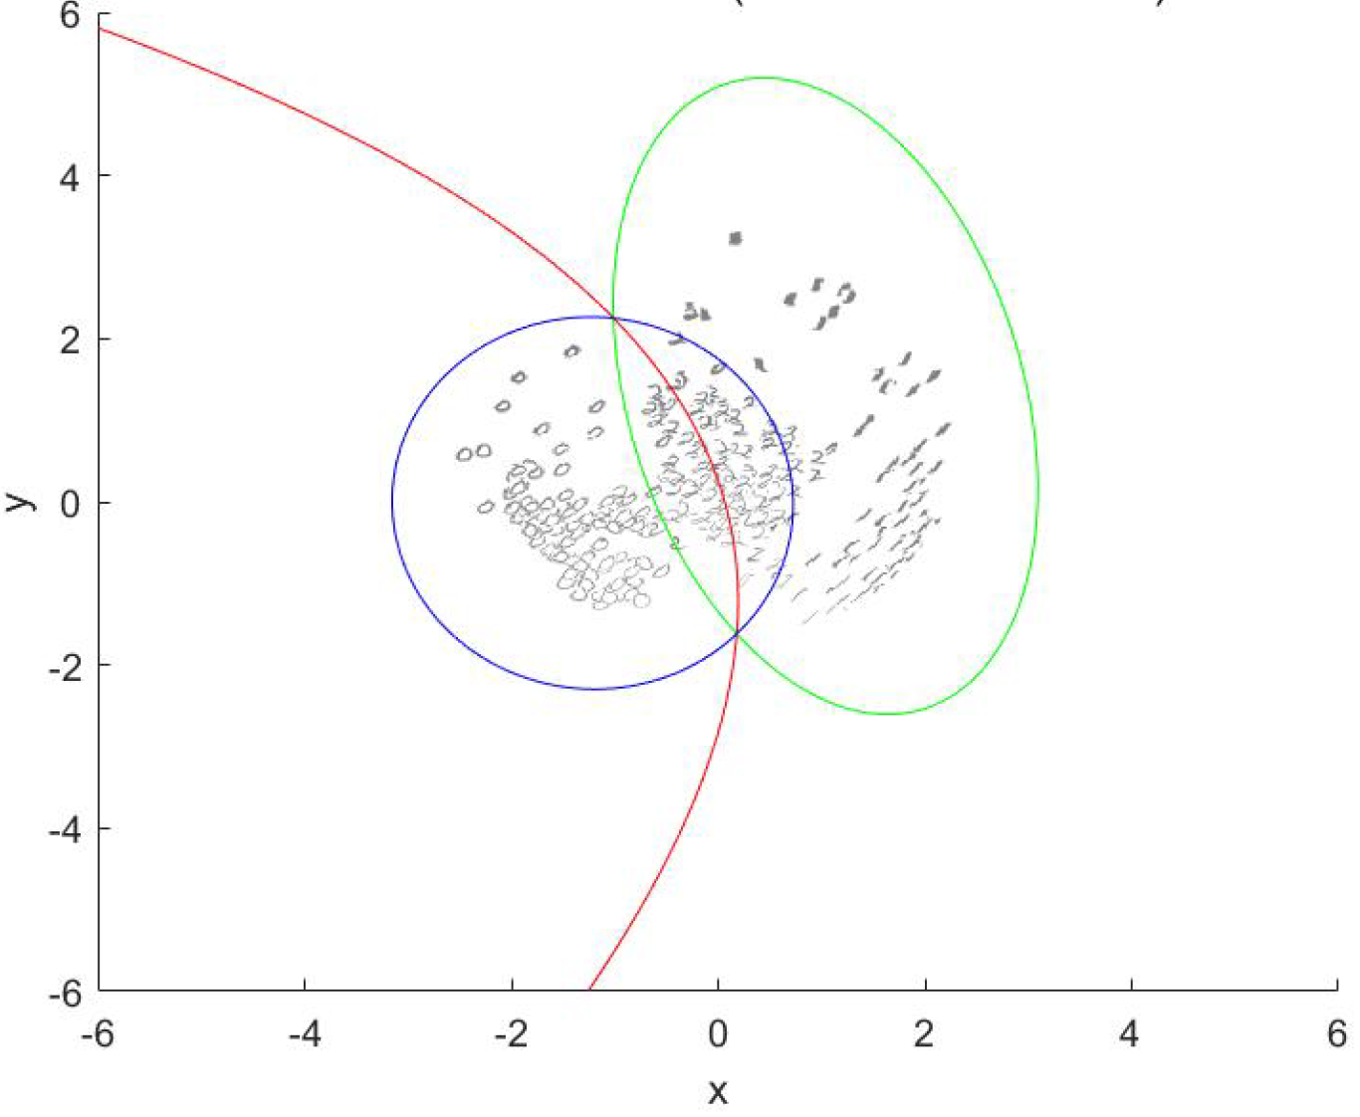

(e)

h=zeros(3,300);

SIGMA=ones(64,64);

for i =1:300

    h(1,i)=X(:,i)'*mu1-(1/2)*mu1'*mu1+log(1/3)

    h(2,i)=X(:,i)'*mu2-(1/2)*mu2'*mu2+log(1/3)

    h(3,i)=X(:,i)'*mu3-(1/2)*mu3'*mu3+log(1/3)

end;

[Y,I]=max(h,[],1);

R=[repmat(1,1,100),repmat(2,1,100),repmat(3,1,100)];

error=1-sum(I==R)/300;

error=0.0733

(f)

Yes and the code is below. The difference is in (f) we do not choose main components, but in (c) we conduct PCA and find the first 2 main components and using data with dimension 2*300

mu1=mean(X(:,1:100),2);

mu2=mean(X(:,101:200),2);

mu3=mean(X(:,201:300),2);

Sigma=cov(X');

est=zeros(1,300);

for i=1:300

[com1,com2]=max([-(X(:,i)-mu1)'*inv(Sigma)*(X(:,i)-mu1),-(X(:,i)-mu2)'*inv(Sigma)*(X

(:,i)-mu2),-(X(:,i)-mu3)'*inv(Sigma)*(X(:,i)-mu3)]);

resulte(1,i)=com2-1;

end

true=[repmat(0,1,100),repmat(1,1,100),repmat(2,1,100)];

errorrate1=1-sum(est==answer1)/300;